NETWORKING - STRUCTURED CABLING

- CATx Stripping and Terminating
In this section we describe the process of stripping and terminating CAT5 cabling. This process will be the same if you chose to use CAT5e cabling. I haven't researched CAT6 cabling on detail enough to describe that process yet so for the time being I'll ignore CAT6.
The Cable
First a brief description of the CATx cable itself. CATx is a term I use to describe CAT5 and CAT5e and CAT6. CATx cables have 8 conductors grouped as four twisted pairs. It's the twisted pairs that are key to the ability of these cables to carry such high speeds digital signals (100 Mbps) over such a long distance of 100 meters. Some things common to CAT5, CAT5e and CAT6 cable are - they all have four twisted pairs and they all use the same color wires. See the CAT5 and CAT5e cables in the photo below. Notice how the pairs consist of a solid colored insulated wire paired with a white colored insulated wire that has a stripe of the same color as the solid wire. Note here too how CAT5 and CAT5e look so similar. CAT6 cable is available despite the fact that the final specifications for CAT6 have not been approved yet.
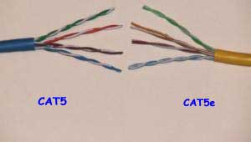
For all practical purposes you can work with these three CATx types in the same manner. When there is a difference I'll point that out. The two important 'rules' to remember are:
Do Not remove any more of the cables jacket than you absolutely have to.
The un-twisted part of the wires CANNOT exceed 1/2".
These rules are intended to limit how much you can untwist the twisted pairs. So lets move on.
The Connectors
Second here is a brief description of the RJ45 connector. The RJ45 connector is called a 'modular connector'. In the context of these connectors I don't know what the significance of the term modular is. But, whatever, the RJ45 connector looks a lot like the standard telephone connector which is called an RJ11. The RJ45 is larger than the RJ11 because the RJ45 has room for 8 conductors where the RJ11 has room for only 6 conductors. See the photos of the two plugs below. The RJ11 is on the left and the RJ45 on the right.
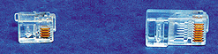
The two jacks that the plugs mate with have the same conductor count and size differences. See the photos of the two jacks below. The RJ11 is on the left and the RJ45 on the right.
The Standards
Stripping CATx cables and terminating CATx connectors is really easy but it does take some finesse, practice, time and patience. But before we get into the How To part of it lets first decide on which wiring standard to use.
You'll likely be somewhat confused by the wiring standards. The standard called EIA/TIA-568-A describes a 'Commercial Building Wiring Standard'. Within this EIA/TIA-568-A standard are two defined wiring 'patterns' for CATx cabling: T568A and T568B. The EIA/TIA-568-A is less of a concern to someone who is wiring their Office with network wiring. What is of concern to the Office network are the two wiring patterns T568A and T568B.
The meat of all this for the Office network are the two wiring patterns. These wiring patterns are illustrated below as they apply to RJ45 plugs.

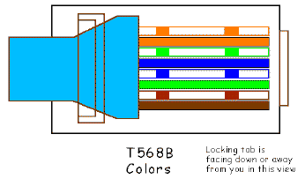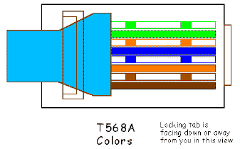
Here is an area that confused me for quite some time. Fortunately, there is a simple answer.
The EIA/TIA-568-A 'Commercial Building Wiring Standard' specifies TWO DIFFERENT wiring color pattern for 8-pin RJ45 connectors. One color pattern is T568A and the other is T568B as shown above. Whatever they say - the meat of the matter is that these two different looking wiring standards are ELECTRICALLY BOTH THE SAME IF you use the SAME color pattern on BOTH ends of a given cable! regardless of which of the two color pattern you choose pin 1 on one end is connected to pin 1 on the other end. Pin 2 on one end is connected to pin 2 on the other end and so forth. The difference is just in the COLOR of the wires. The important thing here is to decide on JUST ONE color pattern and DO ALL your wiring with that pattern you chose.
It really doesn't matter which you chose. Here's how I decided on which pattern to use. I went to my local Comp USA and bought a pre-made CAT5 cable. It was wired to the T568B standard so that is what I chose to use for ALL of my wiring. That's the simple solution - just pick one pattern and stay with it. Now that I have decided to use the T568B standard for all my wiring - if I were to go to say Radio Shack and buy a pre-made CAT5 that has been made to the T568A standard I CAN still use it just fine. I'll repeat - It doesn't matter which standard you use as long as both ends of a given cable use the same standard. The only thing to avoid here is using T568A on one end of a cable and T568B on the other end. This WILL NOT work.
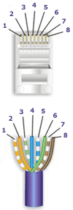 | 568-B Wiring | 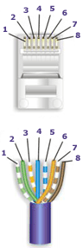 | 568-A Wiring
  Pair # | Wire | Pin #
  1 - White/Blue | White/Blue | 5
  1 - White/Blue | Blue/White | 4
  2 - White/Orange | White/Orange | 1
  2 - White/Orange | Orange White | 2
  3 - White/Green | White/Green | 3
  3 - White/Green | Green/White | 6
  4 - White/Brown | White/Brown | 7
  4 - White/Brown | Brown/White | 8
  << 568-B Diagram
  Pair # | Wire | Pin #
  1 - White/Blue | White/Blue | 5
  1 - White/Blue | Blue/White | 4
  2 - White/Green | White/Green | 1
  2 - White/Green | Green/White | 2
  3 - White/Orange | White/Orange | 3
  3 - White/Orange | Orange/White | 6
  4 - White/Brown | White/Brown | 7
  4 - White/Brown | Brown/White | 8
  << 568-A Diagram
Note:
1. For patch cables, 568-B wiring is by far, the most common method.
2. There is no difference in connectivity between 568B and 568A cables. Either wiring should work fine on any system.
3. For a straight through cable, wire both ends identical.
4. For a crossover cable, wire one end 568A and the other end 568B.
5. Do not confuse pair numbers with pin numbers. A pair number is used for reference only (eg: 10BaseT Ethernet uses pairs 2 & 3). The pin numbers indicate actual physical locations on the plug and jack.

CATx jacks, well at least the Leviton ones that I used, have printed on the side of them the color codes for both standards. See the photo below. The A and B on the side correspond to T568A and T568B.

Working with T568B;
Before we get too far into this process let’s see how you can dress up the looks of your CATx cables and at the same time make them more robust. A vinyl boot can be put over the cable BEFORE the RJ45 connector is crimped on. See the photo below:
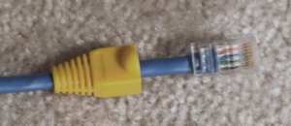
These boots are really nice. They are cheap - about 20¢ each, come in many colors and are easy to use. And you can use them to color code your cables if you wish. Just REMEMBER to put them over the cable BEFORE you crimp on the RJ45 connector. Of course the use of these boots is entirely up to your personal preference. You don't NEED these boots.
Now lets see how to terminate an RJ45 plug on the end of a CATx cable. You NEED a CATx cable stripper. The Cable Stripper is used to remove overall CATx cable jacket that surrounds and protects the paired wire conductors inside. The stripper will help ensure that you don't nick the paired wires inside as you remove the jacket. Shown below is a photo of a typical cable stripper.
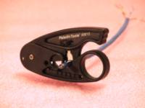
You DON'T have to strip the insulation off of the individual paired wires. Just remove about 1 1/2 inch of the jacket as shown below. The way the stripper tool shown above works is the cable is inserted into the stripper and then the stripper is rotated a couple of times allowing the tools cutting blade to score the cables jacket.
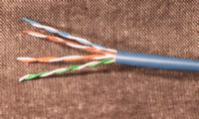
Next is to untwist the twisted paired wires. Then arrange them in the order. Getting the eight wires arranged in the proper order and pressing the eight wires FLAT between your thumb and index fingers is an important step to get the wires setup to slide into the RJ45 connector. Once the wires are FLAT and in the right order cut them so they are 1/2 inch long as shown in the photo below.
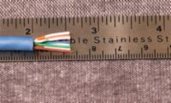
Insert the flattened wire into the the RJ45 connector as shown below:

Now put your RJ45 crimping tool to work. Read the directions for your tool. The drawing below shows what the crimp tool is doing. The crimp tool presses in the gold plated electrical contact down such that they pierce through insulation of all eight wire and make contact with the copper conductor. This is called insulation displacement and is why there is no need to strip the insulation off of the individual wires. The other thing the crimp tool does is press down on a hinged tab that grips onto the cables outer jacket to provide a strain relief action and helps to keep the cable and the connector intact.
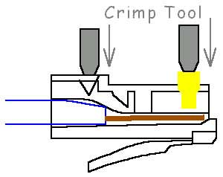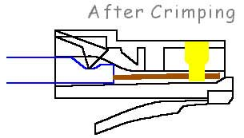
Let's stop here for a brief moment and talk about being neat and following guidelines. Notice in the photo above how jacketed portion of the cable goes all the way up into the plug. This is right way to do this. DO NOT leave portions of the cable exposed without a jacket covering it. This jacket is key to keeping the all important twists in the CATx cable intact and to keep the pairs grouped together.
Do NOT do this! 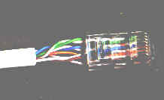
The long lengths of wire that do not have the pairs twisted WILL NOT carry data at 100Mbps. Being neat is more than making it look nice. THIS WILL NOT WORK.
Two key rules that you NEED to follow are:
- Don't untwist the pairs more than 1/2".
- Make sure the cables outer jacket goes into the RJ45 connector and hinged strain relief holds it in place.
This step which is shown above on this page is key to meeting these two rules.
There you have it.
The next page will show how to terminate the CATx to a RJ45 or RJ11 jack and to a Punchdown block.

Summarized Patch Cable Assembly Instructions
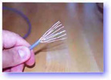 | 1) Skin off the cable jacket approximately 1" or slightly more.  2) Un-twist each pair, and straighten each wire between the fingers.  3) Place the wires in the order of one of the two diagrams shown above (568B or 568A). Bring all of the wires together, until they touch.  4) At this point, recheck the wiring sequence with the diagram.  5) Optional: Make a mark on the wires at 1/2" from the end of the cable jacket. | 8) Insert the wires into the connector (pins facing up). | 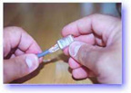
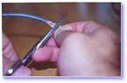 | 6) Hold the grouped (and sorted) wires together tightly, between the thumb, and the forefinger.  7) Cut all of the wires at a perfect 90 degree angle from the cable at 1/2" from the end of the cable jacket. This is a very critical step. If the wires are not cut straight, they may not all make contact. We suggest using a pair of scissors for this purpose. | 9) Push moderately hard to assure that all of the wires have reached the end of the connector. Be sure that the cable jacket goes into the back of the connector by about 3/16". | 
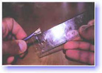 | 7B) Conductors should be at a straight 90 degree angle, and be 1/2" long, prior to insertion into the connector. | 9) Place the connector into a crimp tool, and squeeze hard so that the handle reaches it's full swing. | 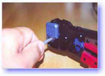
10) Repeat the process on the other end. For a straight through cable, use the same wiring.
For a "crossover" cable, wire one end 568A, and the other end 568B.
11) Use a cable tester to test for proper continuity.

- CATx Stripping and Terminating
This page will show how to terminate the CATx to a RJ45 or RJ11 jack and to a Punchdown block. For these applications you'll need a Punchdown Tool.
The Punchdown Tool
Several suppliers make punchdown tool ranging in different prices. The tools in this price range are impact tools. They work by holding the tool in your hand and pressing the tool down on the CATx wire as it sits in the Insulation Displacement Contact (IDC) slots that these jacks employ. As you press on the tool a spring in the tool is compressed. When the spring becomes compressed to some level the spring releases and 'hammers down' or impacts the CATx wire into the IDC slot. This 'hammering down' or impact action applies a controlled force every time to help ensure a consistent IDC connection. These tools typically have an adjustable impact force and come with interchangeable bits for type 66 and type 110 terminals that are made of high quality tool steel. Even with the tool steel quality bit these will wear out and the bits can be replaced if they wear out. Most of you doing this kind of thing in your own Office will never wear out a bit.
A lot of suppliers sell low cost, non-impact punchdown tool can be very cheap. These tool are made completely out of plastic and will wear out after a few uses and don't have the impact action. Use these all-plastic only if you have a few connectors to terminate.
The photo below shows the most commonly used tool, the D814 made by Harris.
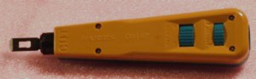
Shown in the photo below are the bits that come with the tool. The bit on the top is for type 110 terminals and the bit on the bottom is for the type 66 terminals and both have stamped on to them a number indicating the size it is intended for. Both these bits are double ended and the left side of the bits will terminate and cut the CATx wire while the side on the right will just terminate the wire and does not cut it.
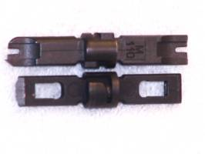
- Terminating CATx to RJ45 and RJ11 Jacks
The RJ45 or RJ11 jacks use the type 110 IDC terminals. You'll need to use the 110 bit for the punchdown tool that will cut and terminate the wire.
Start by removing about 1 1/2" of jacket from the CATx cable. Untwist the entire length of the twisted pairs that are exposed. Lay the CATx onto the jack and arrange the wires into the IDC slots on the jacks using the color code printed on the side of the jack as shown in the photo below. Note here that the color shown below are for the T568B wiring standard that I chose to use.
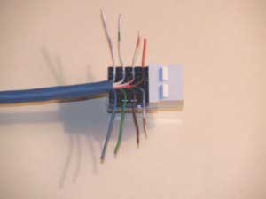
Let's stop here for a brief moment and talk about being neat and following guidelines. Notice in the photo above how jacketed portion of the cable goes all the way up into the connector. This is right way to do this. DO NOT leave portions of the cable exposed without a jacket covering it. This jacket is key to keeping the all important twists in the CATx cable intact and to keep the pairs grouped together.
Do NOT do this! 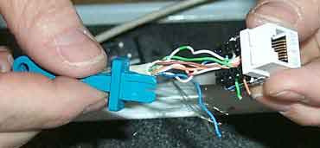
The long lengths of wire that do not have the pairs twisted WILL NOT carry data at 100Mbps. Being neat is more than making it look nice. THIS WILL NOT WORK.
With the type 110 bit in the punchdown tool that will cut and terminate the wire, press the tools bit down onto the terminal with the side of the bit that will cut the wire pointed to the outside of the jack. This is shown in the photo below.
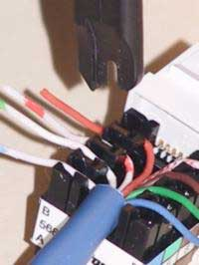
Press down on the tool to compress the tools spring until the tool 'hammers down' or impacts the wire into the terminals slot. This action combined with the wire cutting edge of the bit will terminate and cut the wire.
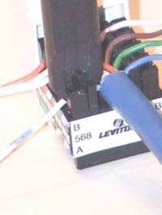

The photo below shows the CATx cable terminated to the RJ45 jack after the wires have been cut by the punchdown tool's bit.
The last step in this process is to snap on a protective cover that is included in the RJ45 and RJ11 jack that will cover the area where the IDC contacts are. That's IT.
- Terminating CATx to Punchdown Blocks
When using CATx for telephone wiring the 'rules' I've stated above can be bent somewhat because telephone signals are not high speed signals and the twists are not quite as critical.
Now that you know how to do basic network 'plumbing' how do you create your own Office Network? The next few pages show you How To...

Notes Regarding Making Category 5 Patch Cable
1) | The RJ-45 plugs are normally made for either solid conductors or stranded conductors. It is very important to be sure that the plug that you use matches the conductor type. It is extremely difficult to tell the difference between the two by looking at them. When you buy these plugs, be sure to categorize, and store them carefully. Using the wrong type can cause intermittent problems. The RJ-45, 8 Conductor Plugs that we sell are rated for both Solid and Stranded cable.
2) | Ordinarily, it would be taboo to untwist the pairs of any category 5 cable. The one exception to this rule is when crimping on RJ-45 plugs. It would be impossible to insert the wires into the channels without first untwisting and straightening them. Be sure not to extend the un-twisting, past the skin point. If you do it properly, you will wind up with no more than 1/2" of untwisted conductors (up to 1/2" of untwist meets the cat 5 specification)
3) | If the completed assembly does not pass continuity, you may have a problem in one, or both ends. First try giving each end another crimp. If that does not work, then carefully examine each end. Are the wires in the proper order? Do all of the wires fully extend to the end of the connector? Are all of the pins pushed down fully. Cut off the suspected bad connector, and re-terminate it. If you still have a problem, then repeat the process, this time giving more scrutiny to the end that was not replaced.
4) | It is good to be prepared to make your own patch cables. There may be many instances where you may fall short on supply, and making a cable will surely get you out of a jam. However, there comes a point where the practicality curve will lead you to factory made cables. Making several cables can be very labor intense. Factory made cables typically have better tolerances, and consequently have better quality than field made cables.

Controversies and Caveats : Category 5, 5E, and Cat 6 Patch Cables
568B vs. 568A |  | For patch cables, 568-B wiring is by far, the most common wiring method. Virtually all pre-assembled patch cables are wired to the B standard. There is no difference in connectivity between 568B and 568A cables. Therefore, a 568B patch cable should work fine on a 568A cabling system, and visa-versa. To my knowledge, there has never been an issue with networks of up to 100 megabits. However, with the advent of Gigabit over copper cabling, it may very well become a factor at some point. We have conferred with several cable manufacturers, and many other technical resources, on this subject. The consensus is that mixing of the standards on patch cables should not cause a problem. Since Gigabit networks over copper cabling are in their infancy, and no one can say for sure, we would advise our customers to take the safe approach on all future patch cable orders. We now offer our custom cat 5E and category 6 cables in both 568A and 568B wiring schemes for this reason.
Re-use of old cables |  | We have seen this happen time and time again. Perfectly good patch cables that have been working fine for years, get removed from their installation, and re-installed on the same, or different network. The result can be a nightmare. What happens is that the cable, over time, adapts to the way that it is bent in it's original installation. When these cables are removed and re-installed, they can either completely loose their connection, or develop intermittent problems. This is due to stresses that may be opposite to what they were originally subject to. If the integrity of your network is more valuable than the price of new patch cables, then we strongly suggest that you use brand new cables for all closet cleanups, network moves, etc.
Stranded vs. Solid wire |  | Almost all patch cables that are made have stranded wire. Stranded wire is normally specified for use in patch cables due to it's superior flexibility. There has been some talk recently, in the technical sector of the structured wiring community, regarding the possible use of solid conductors for patch cables. The reason for the spotlight on solid wire is that it is supposedly more stable, under a variety of conditions. Please note that we now offer custom solid copper category 5E patch cables in Plenum insulation in lengths of up to 295 feet. These cables are suitable for use in air handling (Plenum) ceilings and environments.

Simple Network Wiring and Setup
If all you need is wiring to network multiple PC or to share a remote printer or to allow all of your PC to share a broadband Internet access then all you need is the network wiring. This website has focused on Structured Wiring. If you'll remember from an earlier page I defined Structured Wiring as "combining ALL of the communications wiring in your Office and treating it as one wiring system. This can include wiring for a Office network, telephone, video, audio, alarms, infrared remote control and anything else you choose to throw in." If all you need is the network wiring then all of the concepts and techniques discussed throughout this website still apply - just leave out all of the other wiring types.
You still need a CWP. If all the CWP has to accommodate is network wiring the CWP can be as simple as just a shelf located in some central location. Remember, this central location doesn't have to be in the center of your Office. Central is a 'virtual' term here. Central is a 'Office' to run all of your Office runs to. A good place for a network only CWP would be somewhere near the service entry point in your Office where your broadband internet access comes from.
What does your network only CWP have to have in it? Look at my CWP again.
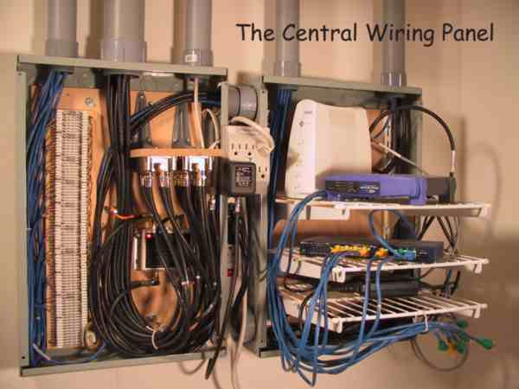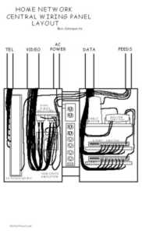
My CWP was designed with the network wiring in the right hand section and the telephone and video wiring on the left hand side. If you just need the network wiring - then you just need the right hand side. Lets take a closer look at the network side.

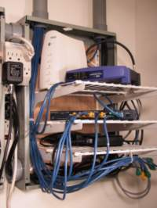
The network part of my CWP is simply an enclosure with three adjustable shelves. What you'll put on these shelves depends on what you want your network to accomplish. More on the contents of the network only CWP later. A lot of commercial CWP's have a patch panel for the network wiring. I believe that for a Office network the patch panel is added expense and complexity that adds little to no value. I won't even describe what a patch panel is or does here. Your network only CWP can be greatly simplified by doing like I did in the photo above - bring all of the CATx cables coming from in from the various locations in your Office, leave yourself a good 3 feet or so of cable length to work at your CWP with and crimp RJ45 plugs on the end of each of the cables. Now you can plug these cables into your hub or your switch or your broadband router or whatever.
Configuring the Hardware
So what do you need and how do you hook everything up? Examples of several setups are shown on the next page.
Simple Network Wiring and Setup
Configuring the Hardware
So what do you need and how do you hook everything up? Here are examples of several setups.
Basic Network with 1 Hub or Switch
This is about as simple a configuration as you can get. With this you can have all of your PC networked together and enjoy all of the benefits that affords you.
Brief description of Hubs and Switches and the Uplink port.
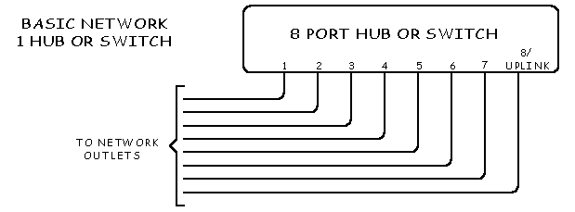

Basic Network with 2 Hubs or Switches
This is still a pretty basic configuration. It shows how to use multiple Hubs or Switches to give you more ports.
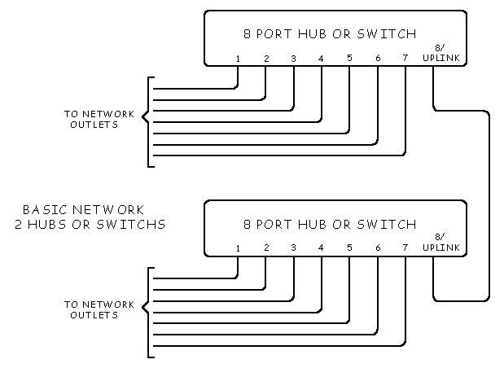
Network with Broadband at the CWP and 2 Hubs or Switches
This configuration adds Broadband access. If you have broadband access in any form such as high speed cable, DSL or whatever you'll need some form of Broadband Modem. Most of these modems come as a stand alone device or as a plug-in PC card. For a networked Office the stand alone device makes the most logical configuration because it will operate independently of any one PC. Locate this broadband modem at the CWP. Now there are MANY manufacturers of these Hubs, Switches and Modem devices and they will likely label their input/output connections differently than I have in these drawings. These drawings just show a generic configuration.
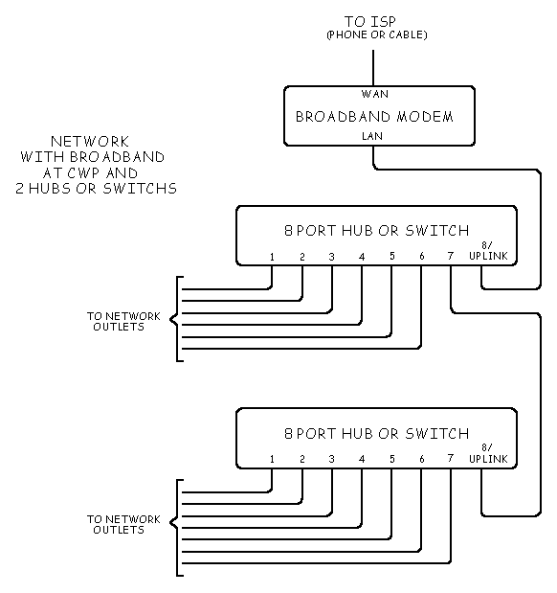
Network with Broadband at the CWP and a Router/Switch and 2 Hubs or Switches -
This configuration adds an ALL IMPORTANT Broadband Router/Switch to your Broadband access. This Broadband Router/Switch adds an important security feature to your network - a Hardware Firewall. This Router will also allow several of your PC's to share one IP address. Without a Router most ISP's will charge you extra for each PC that is sharing their broadband access. The router will allow you to avoid these extra charges. If you have broadband access - GET A ROUTER! They are easy to hookup and are relatively cheaper.
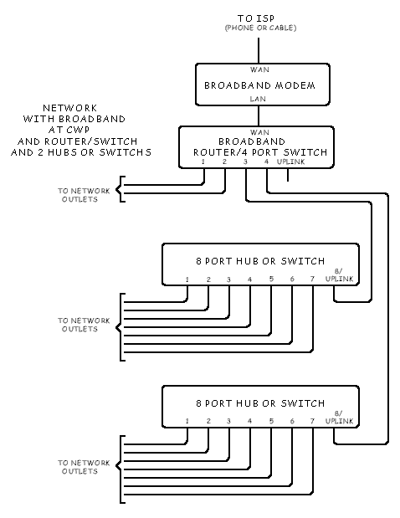
There are Many More Configurations Possible
These are examples of just a few configurations to get you started and to help explain the concept of these various network devices. The next page will briefly describe these devices.

Simple Office Network Wiring and Setup
A Brief and Simplified Description of Various Network Devices
The devices described below are actually quite complex. But fortunately for Simple Office networks you can look at these as relatively simple devices.
Hubs
If you want to network JUST TWO PC's together you can simply connect the ethernet ports on both PC directly together with a ethernet crossover cable. But, if you want to network three or more devices then you need some type of network distribution device. The simplest of these is a hub. Hubs have 4 or 8 or more ethernet ports. When a packet ( ethernet communicates by sending and receiving short messages called packets) comes into any port on a hub the packet is buffered and sent out to EVERY port the hub has. With a hub every PC will receive every packet that any of the other PC's send.
Switches
Switches work in a similar fashion with one key difference. A switch will examine a packet as it comes in and will ONLY pass the packet on to the port that has the device the packet was intended for. A switch will 'learn' the addresses of the devices connected to it so that it knows what port the packet need to go to.
With a hub every port carries every packet that any device sends while on a switch a port only carries traffic intended for the device connected to it. Hubs do not allow multiple devices to communicate at the same time but switches do. With a switch a device on port 1 can be communicating with a device on port 2 at the SAME TIME as another device on port 3 is communicating with a device on port 4. Switches make much more efficient use of a ports bandwidth.
Switches also allow Full Duplex communications. With Full Duplex a port can transmit and receive at the same time.
Routers
Routers are a lot like switches in that they route packets to proper destination. The come in a lot of different forms but for a Simple Office network they usually have the additional task of acting as a bridge between your LAN (Local Area Network) and the WAN (the internet). A router will examine packets and determine if they are destined for your LAN or the WAN and route them accordingly. With a router sitting in-between your LAN and the internet and deciding which packets are allowed to flow between the two, it is in an ideal position to protect the two from each other. This is why most simple Office networking routers have built in firewalls.
Routers have one other huge benefit for people with networked PC that want to share a single internet connection. All your ISP (Internet Service Provider) will see is the router and not the multiple PC behind the router that are sharing the one connection. Without a router the ISP will see each PC and the IP address that each PC has. ISP's usually charge extra for more than one IP address. But, with the router, all the ISP will see is the IP address of the router and the router will make sure that packets to and from the internet get to the proper PC.
Print Servers
A print server is a device that links a printer to a network so that any device on the network can use it. There are two basic way to share a printer among devices that are networked together. The cheapest is to connect the printer physically to one of the networked PC's and then on that PC set the printer up as a shared resource. More on how to do that is coming soon. After this shared resource is setup in the operating system, any of the networked PC's can print to the printer. One drawback to doing it this way is the PC that the printer is connected to needs to be turned on and running anytime another PC needs the printer. In other works, a PC is acting as an expensive print server. The other way of doing it is with a dedicated print server. A print server can be as small as a deck of cards and has at least one printer port and one ethernet port. Mine is a Linksys EFSP42 and has a 4 port ethernet switch and a print server for two printer. A print server is a relatively simple device with no hard drive or cooling fan to wear out so you can leave it powered up all the time ready to serve it's printer(s) on the network . The print server costs extra but it eliminates the need for a PC to be up and running around the clock acting as a print server.
UPLINK Ports -vs- Crossover Cables
You'll notice the drawings on the previous page show ports called UPLINK ports. To understand the purpose of an UPLINK port you need to have a basic understanding of the two types of networked devices. You have Network Distribution Devices and you have Network Users. Network Distribution Devices will be a distribution device like a hub or switch. Network Users will be a PC or a print server or a router or a broadband modem. So here is the rule of thumb:
When connecting like devices such as a hub to a hub or a PC to a PC - use a crossover cable.
Network Distribution Device such as a hub or a switch in intended to be connected to a Network User such as a PC. If you connect LIKE devices you have to use a crossover cable. A crossover cable is the same as a straight through cable except the TX (Transmit) and RX (Receive) pairs are reversed or swapped on ONE end of the cable.
To a network beginner it may not always be clear when you can use a standard cable and when you need a crossover cable. Basically you need a crossover cable when connecting LIKE devices together.
Most manufacturers of hubs and switches know that users will often connect these NDD devices together to add additional ports to a network. With these being LIKE devices a crossover cable is needed. With this in mind, on MOST hubs and switches, one of the ports can usually be configured as an UPLINK port. An UPLINK port has the TX and RX pairs reversed internally to the device, which eliminates the need for a crossover cable. Some devices will have an electrical switch near the port that will change the port to a standard port or an UPLINK port. Other devices will have two jacks for one of the ports with one jack wired as a standard port and the other as an uplink port. When your shopping for a hub or switch look for one that has a configurable UPLINK port!
Crossover Cables
If you must use a crossover cable you can buy them or make them. I have seen 40-11 different descriptions of how a crossover cable is wired. All of them seemed to confuse me so I created my own 40-12th description as shown in the drawings below. To state it as simply as I can - A crossover cable differs from a straight through cable by exchanging or swapping the TX and RX pairs on ONE end of the cable.
The thing that adds to the confusion here, I think, is the fact that there are two wire color patterns - T568A and T568B. As I have said earlier in this website - the meat of the matter is that these two different looking wiring standards are ELECTRICALLY BOTH THE SAME IF you use the SAME color pattern on BOTH ends of a given cable! Regardless of which of the two color pattern you choose pin 1 on one end is connected to pin 1 on the other end. Pin 2 on one end is connected to pin 2 on the other end and so forth. The difference is just in the COLOR of the wires.
So rather than explain all this in words I have made drawings of the 4 possible cable configurations. You have two wire color standards and you can have a straight through and a crossover version of each. All 4 are shown below:
T568B Colors
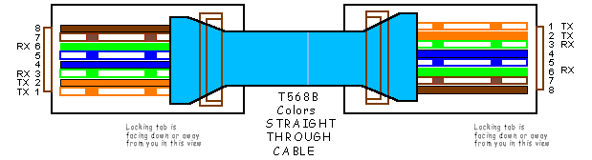
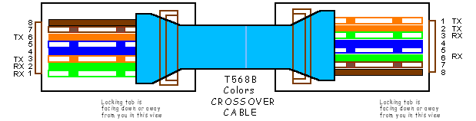
T568A Colors
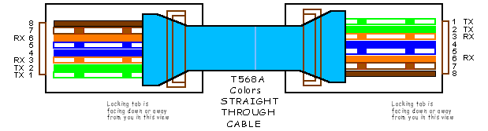
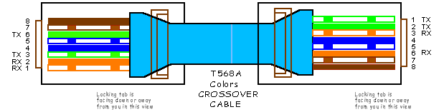
Summary
- Use a crossover cable to connect LIKE devices. For un-like devices use a straight through cable.
- To make a crossover cable you reverse the TX and RX pairs on ONE end of the cable.
- When your connecting a hub to a hub or a switch to a switch - you don't have to use crossover cables if the hub or switch has an UPLINK port. Simplify things by choosing devices that have UPLINK ports!!
- When your connecting a hub to a hub or a switch to a switch using an uplink port, connect one end of a straight through cable to an UPLINK port and the other end of the cable to a standard port. Remember - you are essentially swapping the TX and RX pairs on ONE end of the cable only. This is why you connect one end of the cable to an uplink port and the other end to a standard port.
- Another thing. If you make or buy a crossover cable it will look a LOT like a straight through cable. Make sure you label a cable clearly as being a crossover cable. You can spend hours troubleshooting a problem that arises because you used the wrong kind of cable.
Simple Office Network Wiring and Setup
Configuring Your PC's Operating System for a Network
I'll just deal here with windows. Sorry, that's the only operating system I use. And actually I'm going to refer you to other sites that have already described this process better that I can.
The illustration that follows shows people that have computers behind a functioning hardware firewall, broadband router, Microsoft ICS or other Internet sharing software.
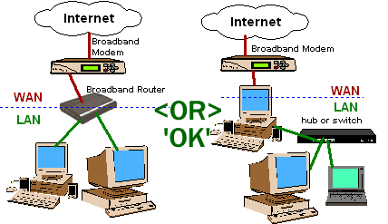

This illustration is intended for people that only have a hub or switch between their computers and their broadband Internet connection. If you do only have a hub or switch between your 'LAN' and your broadband modem, then you should never enable file or print sharing. If you follow this illustration, you may be giving everyone on the Internet access to your network shares.
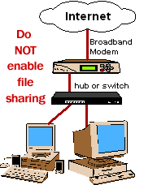
Security Concerns
One thing I do want to stress to you here is network security. If you don't configure windows properly you can end up with a network that leaves your entire file EXTREMELY VULNERABLE to snoops and intruders - and hacking this kind of network is VERY EASY!
The single most dangerous network configuration is one that enables 'File and Printer Sharing'. File and Printer sharing allows the PC's on your LAN to - guess - share files and printers. This is something most simple Office networks will want to take advantage of. But, when you enable this file and print sharing service on your Windows PC the Microsoft DEFAULT setting leave your system vulnerable. Microsoft seems to care less about the security of your simple Office network. If you use a Microsoft operating system then you'll have to alter the default networking setting to dramatically increase the security of your network.

